Assignment 3

The design of the TechSupport database
The TechSupport database is used to track technical support incidents for a small software company. It consists of the six tables shown in the diagram that follows. The main table is the Incidents table, which contains one row for each technical support incident. Each row in the Incidents table is related to one row in the Customers table, which contains information about the company’s customers; one row in the Products table, which contains information about the company’s products; and one row in the Technicians table, which contains information about the company’s technical support staff. In addition, a table called Registrations keeps track of products that are registered to each customer, and the States table contains state and zip code information.

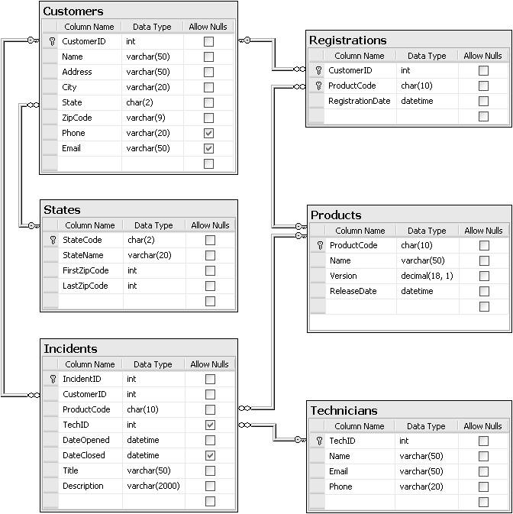
In addition to the column properties shown above, you should know that the CustomerID, IncidentID, and TechID columns in the Customers, Incidents, and Technicians tables are identity columns. So the values of these columns are set automatically when new rows are added to these tables.
Part A: Display registered products by customer
For this project, you’ll enhance the SportsPro application by adding a form that displays the products that are registered to a customer. To do that, you’ll use LINQ to DataSet with a typed dataset and data views. (Required reading: chapters 11 and 12.)
The Products by Customer form
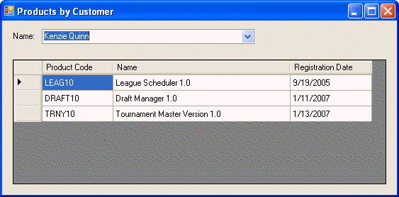
Project items
Name Description
frmCustomerProducts A form that displays the products registered to the selected customer.
TechSupportDataSet4A A typed dataset with two tables named Customers and Registrations.
Operation
- The Products by Customer form should be displayed when the user chooses the Registration→Display Products by Customer command from the menu on the main form.
- To display the registered products for a customer in the DataGridView control, the user selects a customer from the combo box.
Specifications
- Use the Data Source Configuration Wizard or Dataset Designer to create a dataset schema that includes the Customers and Registrations tables. The schema should include just the columns used by this form.
- Modify the Select statement for the query that fills the Registrations table so it includes the Name column from the Products table.
- Generate the combo box and DataGridView controls from the Customers and Registrations tables, and then format the controls so they look as shown above.
- Use LINQ to retrieve the data for the combo box, and sort the results by name. Bind the combo box to a data view that’s created from the query results.
- Use LINQ to retrieve the products that are registered to the customer that’s selected from the combo box, and sort the results by registration date. Bind the DataGridView control to a data view that’s created from the query results.
Tip
- Because the combo box and data grid are generated from the Customers and Registrations tables, you don’t need to import the namespace that contains the table adapters and you don’t need to create an instance of the dataset or table adapters in code. Instead, you can use the dataset and table adapters that are generated when you create the controls.
Part B: Display incidents by customer
For this project, you’ll enhance the SportsPro application by adding a form that displays customer and incident information for a selected customer. To do that, you’ll use LINQ to SQL and object data sources. (Required reading: chapters 11 and 13.)
The Customer Incidents form
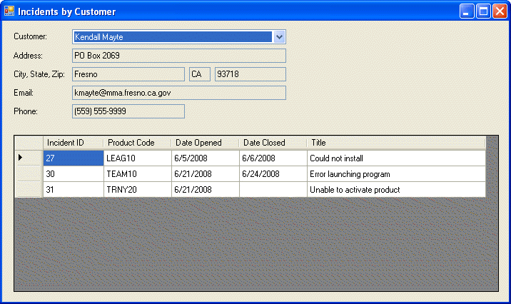
Project items
Name Description
frmCustomerIncidents A form that displays customer and incident information for a selected customer.
TechSupport.dbml An object model with two entity classes named SQLCustomer and SQLIncident.
DataContext A static class that contains a declaration for a data context object named techSupportSQL.
Operation
- The Customer Incidents form should be displayed when the user chooses the Incidents→Display Incidents by Customer command from the menu on the main form.
- To display the customer information and incidents for a customer, the user selects a customer from the combo box.
Specifications
- Create an object model from the Customers and Incidents tables in the TechSupport database. Use the O/R Designer to change the names of the entity classes that are generated as indicated above so the names don’t conflict with the names of the classes in the TechSupportData class library.
- Code the statement that creates the data context object in a static class named DataContext so it can be used by any form in the application.
- Use object data sources to generate the controls on the form, and format the controls as shown above.
- Use a LINQ query to retrieve the customer data needed by the combo box and sort the results by customer name. Bind the combo box to the results of this query.
- Use a LINQ query to retrieve the data for the selected customer, and bind the text boxes to the properties of the selected customer.
- Bind the DataGridView control to the incidents for the selected customer using the relationship between the customer and incident classes.
Part C: Assign Incidents
For this project, you’ll enhance the SportsPro application by adding two forms that let a user assign incidents to technicians. To do that, you’ll use LINQ to SQL. (Required reading: chapters 11, 13, and 14.)
The Unassigned Incidents form
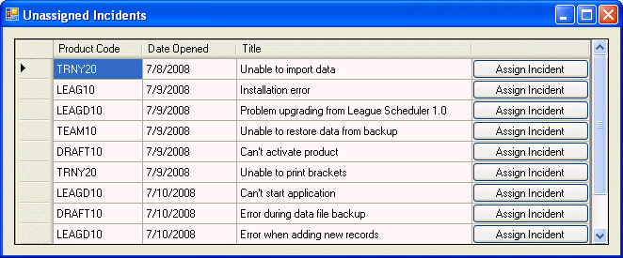
The Assign Incident form
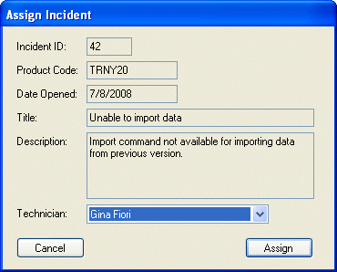
Project items
Name Description
frmUnassignedIncidents A form that displays the incidents that haven’t been assigned to a technician.
frmIncidentAssignment A form that lets the user assign an incident to a technician.
TechSupport.dbml An object model with two entity classes named SQLIncident and SQLTechnician.
DataContext A static class that contains a declaration for a data context object named techSupportSQL.
Operation of the Unassigned Incidents form
- The Unassigned Incidents form should be displayed when the user chooses the Incidents→Assign Incidents command from the menu on the main form.
- To assign an incident to a technician, the user clicks the Assign Incident button for the incident to display the Assign Incident form.
Specifications for the Unassigned Incidents form
- Create an object model from the Incidents and Technicians tables in the TechSupport database. Use the O/R Designer to change the names of the entity classes as indicated above so the names don’t conflict with the names of the classes in the TechSupportData class library.
- Use an object data source to generate the DataGridView control, and format the control as shown above.
- Use a LINQ query to retrieve the data for the DataGridView control and sort the results by the date opened. Return only the columns needed by the data grid. Bind the data grid to the results of this query.
- Code an event handler for the CellContentClick event of the DataGridView control. This event handler should get the Incident ID from the selected row when the user clicks the Assign Incident button in that row. Then, it should display an instance of the Assign Incident form whose Tag property is set to the incident ID.
- If an incident is assigned successfully or a concurrency conflict occurs, the data that’s displayed in the DataGridView control should be updated.
Operation of the Assign Incident form
- The Assign Incident form should be displayed when the user clicks an Assign Incident button on the Unassigned Incidents form.
- To assign an incident to a technician, the user selects a technician from the combo box and clicks the Assign button. After an incident is assigned, control returns to the Unassigned Incidents form.
- To return to the Unassigned Incidents form without assigning the incident to a technician, the user clicks the Cancel button.
Specifications for the Assign Incident form
- Use the Tag property of the form and a LINQ query to retrieve the incident that’s displayed on the form.
- Use a LINQ query to retrieve the data for the Technician combo box and sort the results by technician name.
- When the form is first displayed, no technician should be selected in the combo box. Then, you can check that a technician has been selected before an incident is assigned.
- Include code to handle any SQL Server or concurrency errors that occur when an incident is updated. Only the technician ID should be checked for concurrency errors since this is the only value that can be changed for an unassigned incident.
- Return a DialogResult value that indicates the result of this form to the Unassigned Incidents form.
Tips
- If you did PART B you can add an entity class for the Technicians table to the existing object model.
- To determine if an incident has been assigned to a technician, you can check the HasValue property of the TechID column since the TechID column is nullable.
- It isn’t necessary to resolve concurrency conflicts when they occur because if the incident has been assigned, it will no longer be included in the query results.

Submitting your assignment

This project is to be done independently. To submit your assignment:
- Create a zip file containing your entire project (using Windows, Winzip or Winrar)
- Name this zip file using your full name
- Email the file to danny@321sd.com with the subject line:
CXEC 305 – A3
- You must submit your assignment before the due date. The timestamp of the electronic submission will determine if you have met the deadline.

If you find that there is a problem with your submission and must resubmit it, please use an alternate filename extension, (e.g, joesmithV2.zip) and email it with an alternate subject line (e.g., CXEC 305 – A3 v2).

It is your responsibility to submit a file that is working properly!

